Sub project 2.

Extension of the Mongolian national backbone network in remote areas

1. Project common information
In recent years, technological advancements and service types and quality have increased inasmuch as consumers have to receive and transmit high-speed data, and they are faced with a situation in which to increase the capacity of the network, balancing load and optimizing the structure.
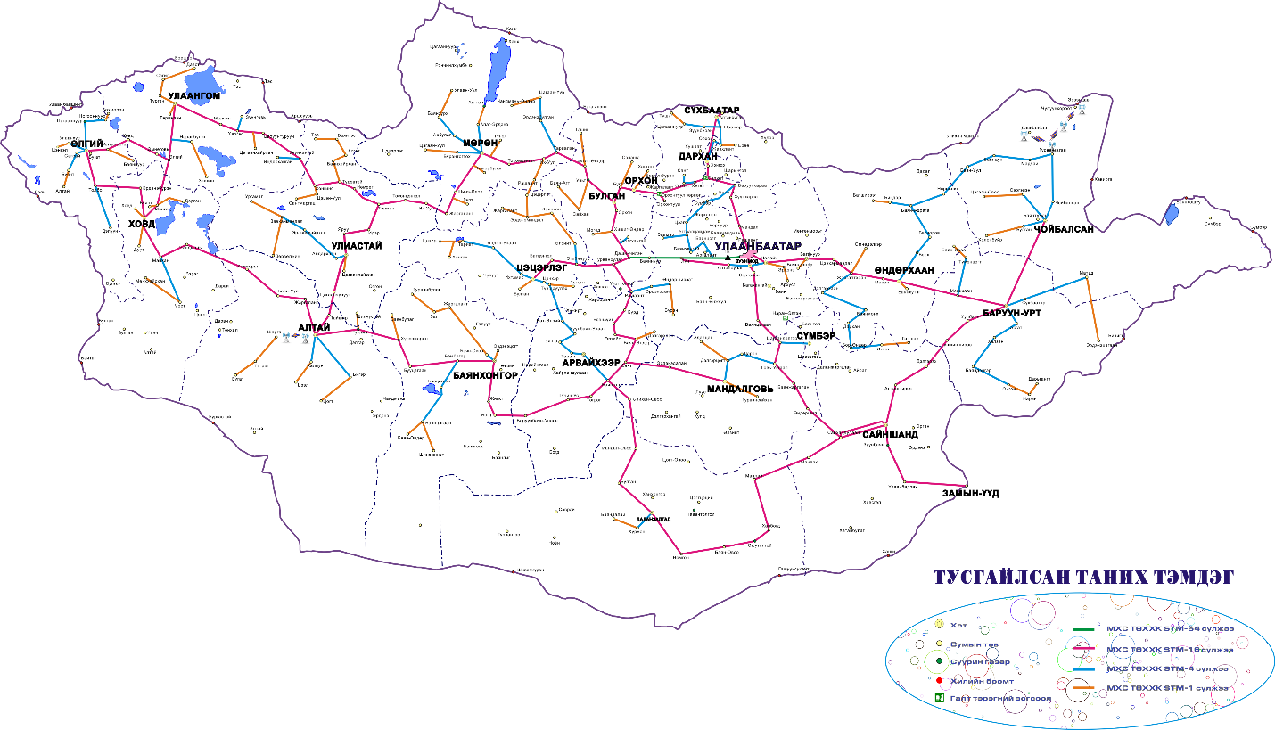
Picture 7. Mongolian national backbone network
Picture 8. Growth of the 3G and 4G mobile subsribers/CRC statistics 2016/

- 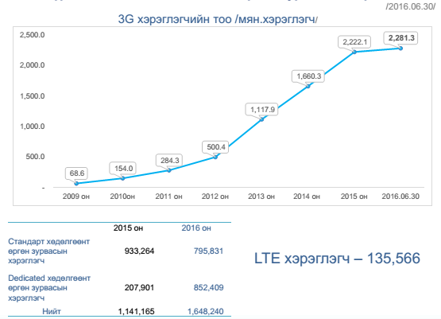

The number of users receiving mobile broadband services is projected to grow rapidly, by 2017 the fiber-optic infrastructure is inevitably needed in the rural areas as the only 4G mobile service.
The organization’s of data traffic usage to increase their flow rates depending on the company’s use of technological innovation and video content and requests for pay attention to the capacity of the backbone network from internet provider company’s that service on rural areas.
In 2016, the number of international fixed broadband subscribers decreased by 15 million and mobile subscribers increased by 91 million. According to Huawei and Ovum, mobile 4G data transmission is expected to increase by 15 percent in 2016 and by 75 percent in 2020.
Since 2003, the number of portable electronic devices for personal use has increased by 3 units per person and by 2020 the number of electronics per person per capita is expected to increase 7 by the end of the year.

2. Project needs

Benefits and impacts of the project on the political, economic and social development of the recipient country.
The objective of this project is to connect the rural Mongolia with the scarce connectivity to the fiber optic cable network and to establish the infrastructure requisited for high speed internet and communication service’s provision to citizens and organizations. The necessity to build high speed broadband network at soums arises from the policy environment, regarding constitution of fundamental information and communication infrastructure and establishment of high speed broadband network.
Using telephony or private satellite communication system, as deprived of fiber optic cable network connectivity, soums conduct limited provision of service and information to the costumers and public sectors. Therefore, connecting soums to the fiber optic cable network is mandatory, as it is accelerates provision of communication service.
Mongolian government aims to upgrade and renovate port facilities and equipments, update custom’s electronic information system within the scope of the border service improvement work. Consequently, preparation work for one-stop electronic system of foreign trade will be done.
Fundamental infrastructure of fiber optic cable and high speed network service is principal for efficient usage of above mentioned system and integrated system of civil registration and pasport control.

Association of project and recipient country’s development plan.
Low capacity network in Ulanbaatar- provinces- soums directions causes difficulties to the service providing companies in internet service and other digital services provision. There is necessity to execute distance learning, distance therapies, diagnostics and digital e-services based on modern information and communications technologies to improve living standards of population in rural areas.
This project is necessary to ensure the fulfillment of the article 5.1.18 of Action program of government of Mongolia for 2016- 2020 – “Implement a program on ensuring a safe living environment for rural dwellers and a better access to information for cattle-breeders and provide equal opportunities for them to take part in their soum and bag activities regardless of distance” and to eliminate the digital difference in urban and rural population.
This project will contribute to the fulfillment of the article 5.4.14. of Action program of government of Mongolia for 2016 - 2020 - “Ensure the security and protection of state borders and build the capacity through renewing the communication equipment supply for state border protection, increasing the capacity of border check points, creating a management and control system based on a broadband network connecting border check points…” and to constitute fundamental infrastructure of broadband network to associate operations of civil registration, custom and taxation.
Necessary to implement following phases inticated in “Mongolia sustainable development vision- 2030”:
  - Provide high-speed internet connection for 70 percent of the population, enforce the same price/tariff across all territories, and increase the transit network capacities running through the high-speed network connecting Asia and Europe. (2016-2020),
  - Provide high-speed Internet connection for 90 percent of the populatin, ensure that at least 70 percent of the rural populations use broadband Internet services, and digitize no less than 50 percent of public services. (2021-2025)
  - Provide high-speed Internet connection for 95 percent of the total population, digitize no less than 85 percent of public services, and launch and use a national satellite. (2026-2030)
Therefore, there is an urgency to extend the network infrastructure to meet the demands of modern technology to spread the service through the rural area and deliver digital services to citizens.

3. Project description

Project cost
The project aims to establish optical fiber network facility in Mongolian 8 soums without optical network connection and border ports which needs to use broadband network.
Table 2.1. Cost of the establishment of optical fiber network
№ | Destination |  |  | Source destination |  | OFC / км /
 | Province | № | Soum | Province | Soum | Distance  / км /
1 | Arkhangai | 1 | Khashaat | Uvurkhangai | Khotont | 100
2 | Dornogovi | 2 | Khuvsgul | Dornogovi | Ulaanbadrakh | 75
 |  | 3 | Khatanbulag |  | Khuvsgul | 75
3 | Dornod | 4 | Dashbalbar | Dornod | Gurvanzagal | 65
 |  | 5 | Chuluunkhoroot |  | Dashbalbar | 120
4 | Tuv | 6 | Mungunmorit | Ulaanbaatar | Baganuur | 70
 |  | 7 | Bayan-Unjuul | Tuv | Altanbulag | 90
 |  | 8 | Bayanjargalan |  | Arkhust | 55
Total |  |  |  |  |  | 650

Table 2.2. Cost of the establishment of optical network facility in border ports
 | Port name | Destination | Source destination | OFC Length /км/
1 | Khavirga | Dornod, Choibalsan sum | Choibalsan sum | 80
2 | Baynkhoshuu | Dornod, Khalkh gol sum | Matad sum | 60
3 | Svmber | Dornod, Khalkh gol sum | Matad sum | 130
4 | Bichigt | Sukhbaatar, Erdene tsagaan sum | Erdenetsagaan sum | 75
5 | Zamiin-Uud | Dornogovi, Zamiin-vvd sum | Zamiin-Vvd sum | 6
6 | Khangi | Dornogovi, Khatanbulag sum | Ulaanbaatar- Khovsgol 75 км, Khovsgol- Khatanbulag 75 км, from Khatanbulag 120 км | 120
7 | Gashuunsukhait | Omnogovi, Khanbogd sum | Oyutolgoi uurkhai towiin МХС ХХК-iin bair | 120
8 | Burgastai | Govi-Altai, Altai sum | Tseel - Altai sum 200 км, Altai sumaas burgastai boomt 90 км | 90
9 | Khankh | Khuvsgul, Khatgal sum | Khankh sum | 23
10 | Tes | Ubs, Tes sum | Tes shar vzvvr 50 км | 50
11 | Arts suuri | Zavkhan, Tes sum | Tes sum | 48
12 | Baga ilenkh | Bulgan Teshig sum | Teshig sum | 70
13 | Zelter | Selenge, Tvshig sum | Tvshig sum | 12
14 | Ulikhan | Dornod, Bayn-Uul sum | Bayn-Uul sum | 65
15 | Ereentsav | Dornod, Chuluunkhoroot sum | Chuluunkhoroot sum | 10
16 | Ulaanbaishint | Bayan-Ulgii,Tsagaannuur sum | Tsagaannuur | 30
 | TOTAL |  |  | 989

In addition 4 routes of the national backbone network is using old aerial cable, which is need to renovated to enhance the network capacity to an optimal level, and to establish an efficient system that enables the delivery of reliable network service to the customers.

Хүснэгт 2.3. Renovation of the old optic fiber cable routes
 | Destination Route | OFC Lenght /км/ | Description
1 | Govi-Altai Province Altai- Taishir | 55 | Renovation of central ring east part, which is now using 8 core aerial cable
2 | Taishir – Uliastai | 165
3 | Bulgan - Murun | 360 | Renovation of central ring upper part, which is now using old 8 core aerial cable
4 | Khovd - Ulaangom | 255 | Renovation of west ring, which is now using old aerial cable
 | Нийт | 1215

Хүснэгт 2.3. Establishment of China-Mongolia route through Asian Highway 3 to south
№ | Destination Route |  |  | Source destination |  | OFC / км / | Cost /USD/
 | Province | № | Soum | Province | Soum | Distance / км /
1 | Tuv | 1 | Bayan | Ulaanbaatar | Nalaikh | 630
 |  | 2 | MW405 | Tuv | Bayan
2 | Dornogovi | 3 | Bayantal | Dornogovi | MW405
 |  | 4 | Choir |  | Bayantal
3 |  | 5 | Dalanjargalan |  | Choir
 |  | 6 | Airag |  | Dalanjargalan
 |  | 7 | Sainshand |  | Airag
4 |  | 8 | Urgun |  | Sainshand
 |  | 9 | Erdene |  | Urgun
 |  | 10 | Zamiin-Uud |  | Erdene
4 | Tuv | 11 | Bayangol | Tuv | Bayanchandmani | 90
5 | Darkhan-Uul | 12 | Darkhan |  | Bayangol | 80
Total |  |  |  |  |  | 800

The location and conditions of the project implementation

The project aims to establish optical fiber network facility in Mongolian 7 remote soums/small town/ without high speed broadband network.
The 8 soums of rural Mongolia with the scarce connectivity to the fiber optic cable network establish the infrastructure requisited for high speed internet and communication service’s provision to citizens and organizations. Installation of fiber optic cable shall use aerial cable for difficult environmental conditions.
At the current situation there are 16 border crossing points which need to be delivered to the fiber optic network, which connects 12 frontier ports to the fiber optic network, which enables interconnection of civil registration, customs and tax information system.
Installation of Fiber Optic Networks shall begin with a detailed survey of the route and installation shall be carried out in accordance with relevant Mongolian standards and approval of the conservation network of the communication network with the local authorities.

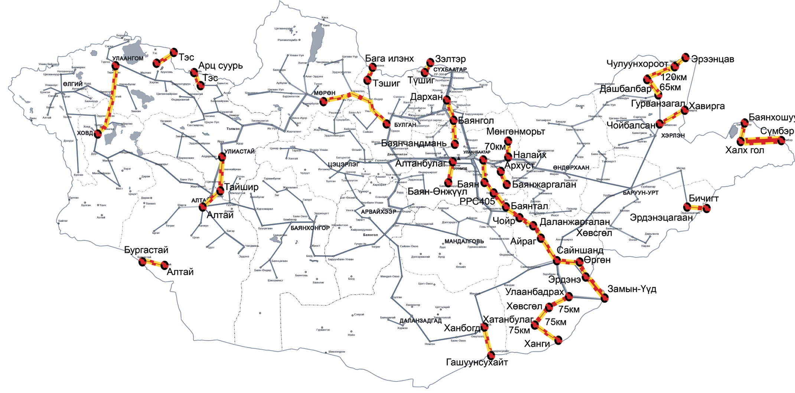
Picture 10. OFC work destinations

